Name:  Class: | ____________________________________  ________________ |  | Date:_________
 | Year 11 Essential Mathematics 2018  / 12  Weighting: 1%  Mini-Test 1.5  Topic – Units of Energy
Total Time: | 15 minutes
Weighting: | 1%
Equipment: | To be provided by the student: Pen, pencil, ruler,1 single sided A4 page of notes, scientific calculator

Full working out must be shown to get full marks. Attempt all questions.

Question 1 4 marks

Convert the following to kilojoules.
- i) 6070 joules ii) 250 calories iii) 867 joules iv) 5.8 Wh

Question 2 1 mark

An air conditioner has a power rating of 3.2 kW. Write this rating in watts.

Question 3 1 mark

During swimming training, Michael swam for 90 minutes burning off 3900 kJ of energy.

How many calories did he burn?



Question 4 3 marks

Jayme has a recommended daily intake of 8700 kJ. She eats 60g of a fruit and nut trail mix with the following nutritional information.
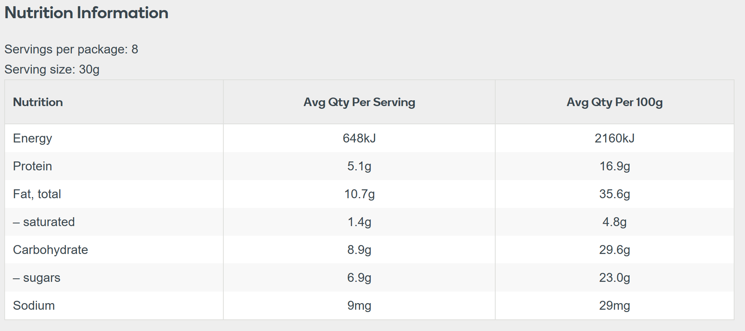
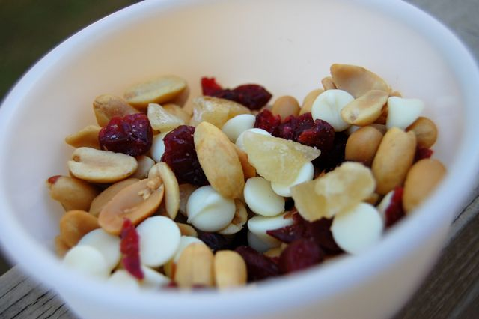
- How many kilojoules of energy does Jayme consume?
This Photo by Unknown Author is licensed under CC BY-NC-ND
- What percentage of her recommended daily intake is this?

Question 5 3 marks

- Doug’s 60 cm television has a power rating of 150 W, while Jeremy’s 96 cm television is rated at 320 W. They both use their televisions for 1 hour every day. How much less energy will Doug’s television use per year?

- What is the difference in cost in dollars if the cost of energy is 24c/kWh?

